The Optimization of the Heat Dissipation on the LED Package
David T.W. Lin*, Chung-Neng Huang and Chong-Ching Chang
Institute of Mechatronic SystemEngineering, National University of Tainan,Tainan 701, Taiwan

Corresponding author: PhD. Associate Professor David T.W. Lin
Mailing Address: Institute of Mechatronic System Engineering, National University of Tainan, No.33, Sec. 2, Su-Lin St., Tainan, 701, Taiwan
Telephones: +886-6-2603200(office)
Fax: +886-6-2602116
E-mail: david@mail.nutn.edu.tw
Abstract:
For the purpose of saving energy, the green technology of LED’s improvement is investigated in this study. The aim of this article attempts to explore the optimal design of the high power LED package related the thermal characteristics. To achieve the optimal design of the size of the slug inside the LED package is our purpose to improve the heat dissipation. The simplified conjugate-gradient method (SCGM) is adopted to combine with the finite element method to optimize the shape of the slug inside the LED package. The results show that the shape of the slug changing directly affects the temperature profile inside the LED. The heat generated from die can be removed more by the change of the slug. It is obvious that the proposed method is effective on thermal optimization of the LED package. It may give rise to a new insight and more innovative possibilities in the development of the new generation LED.

1. INTRODUCTION
Recently, high power (> 1W) white LED are capable of replacing traditional fluorescent. The high-power LED will creative the significant impact on the solid-state lighting industry [1]. However, the internal stability and reliability of LED affected by the heat problem is still an important issue. Many previous studies have been discussed the temperature profile from the chip level of LED, such as using the nematic liquid crystal measurement [2-3], the compact thermal model [4], the thermal resistor network model [5], and the finite element model [6]. According to these studies, we can understand the adequate thermal management is very important that affect not only the efficiency of the light emission but also the lifetime of the whole system.
It is noted from the paper review cited above, despite its practical importance, that studies of the optimization of a set of design parameters has not received sufficient attention. This motivates the present investigation.
The optimal methods currently used can be broadly divided into two categories: one is gradient based techniques, such as the gradient search method (GSM) [7] and the conjugate gradient method (CGM) [8-9], the other is simulated evolutionary optimization, such as the genetic algorithms (GA) [10] and the simulated annealing (SA) [11].
Optimal shape design of the slug inside the LED model is investigated in this study. Thermal resistance of the LED is the key factor to affect the heat dissipation directly. The slug of the LED is the main structure of dissipating heat generated from die. That is to say, the shape design of the slug is the dominant study for removing more heat. This study proposes an optimal method combined a direct problem solver, COMSOL code, with an optimization method, SCGM. COMSOL is used as the subroutine to solve the thermal-fluid profile during the iterative optimal process.
The SCGM method, proposed by Cheng and Chang [12], is capable of obtaining the minimized objective functions easily, and calculating fast than traditional conjugated gradient method. This study is aimed at the optimization of these design parameters so that the maximum heat dissipation of the high power LED under some specified arrangement of LED’s package requirements.

2. NUMERICAL ANALYSIS
Fig.1 presents a schematic illustration of the LED package considered in the present analysis. As shown, the package combined with the chip die as the heat fluxes between the slug and LED cover. As the heat transfer phenomena are symmetric, the analysis is simplified to be a two-dimensional problem.
The package is denoted as a domain,$V$, the initial temperature is kept as a constant temperature, $T_{i}$. The governing equation about this model is listed as below:
$ρC\frac{∂T}{∂t}=\frac{∂}{∂x}\left(k\frac{∂T}{∂x}\right)+\frac{∂}{∂y}\left(k\frac{∂T}{∂y}\right)+Q$ $(x_{i},y_{i})∈V$ (1)
(2)
$T(x,y,0)=T_{i}$ (3)
The above boundaries are solved by adopting the well-received multi-physics analysis method, COMSOL. In addition, the thermal properties of air used in the computation are given in Ref. [13], which is provided in the nomenclature. In this research, the radiation effect within the cover is also included in the LED model. Here the coefficient of surface emissivity inside the LED cover is set as 0.93.
From the illustrations as above, different combinations of these variables represent different size inside the LED package which the optimal design may be found. In other words, the variables are updated iteratively toward the minimization of the object function in the optimization process.
For the thermal problem considered here, the height of the slug,$d$, is the design variable. In the present study, an objective function,$J^{'}$, in conjunction with the optimization process leading to the desired heat removal of the LED package is defined in the following:
$J^{'}=\frac{\left(T_{1}−T_{2}\right)}{dk}$ (4)
here, $T_{1}$ is the chip temperature, $T_{2}$ is the temperature on the bottom of slug, $k$ is the thermal conductivity of the slug.
In this manner, as the objective function $J^{'}$ is approaching its maximum value in the optimization process, with the definition of$J$approaching its minimum one. Here C is a large number to promise $J$is positive.
$J=C−\frac{\left(T_{1}−T_{2}\right)}{dk}$ (5)
The SCGM evaluates the gradient functions of the objective function and sets up a new conjugate direction for the updated undetermined coefficients with the help of a direct numerical sensitivity analysis. The direct numerical sensitivity analysis is performed to determine the gradient functions${\left(∂J/∂a_{i}\right)}^{n},\left(i=1,2,\text{.}\text{.}\text{.},l\right)$. Firstly, giving a perturbation $\left({Δa}_{i}\right)$ to each of the undetermined coefficients,$\left\{a_{i},i=1,2,\text{.}\text{.}\text{.},l\right\}$, and then finding the change in the objective function $\left(ΔJ\right)$ caused by ${Δa}_{i}$. The gradient function with respect to each of the undetermined coefficients can be calculated by the direct numerical differentiation as
$\frac{∂J}{∂a_{i}}=\frac{ΔJ}{{Δa}_{i}}$ (6)
Then, we can calculate the conjugate gradient coefficients,$γ_{i}^{n}$ and the search directions,$π_{i}^{n+1}$ for each of the undetermined coefficients with
$γ_{i}^{n}={\left[\frac{{\left(\frac{∂J}{∂a_{i}}\right)}^{n}}{{\left(\frac{∂J}{∂a_{i}}\right)}^{n−1}}\right]}^{2},\begin{matrix}i=1,2,\text{.}\text{.}\text{.},l\end{matrix}$ (7)
$π_{i}^{n+1}={\left(\frac{∂J}{∂a_{i}}\right)}^{n}+γ_{i}^{n}π_{i}^{n},\begin{matrix}i=1,2,\text{.}\text{.}\text{.},l\end{matrix}$ (8)
The step sizes $\left\{β_{i},i=1,2,\text{.}\text{.}\text{.},l\right\}$ will be assigned for all the undetermined coefficients and leave it unchanged during the iteration. In this study, the fixed value is determined by a trial and error process, and the value is set to be $1\text{.}0×{\text{10}}^{−6}$ typically. The difficulty lies with the fact that how to decide the suitable value of the step size. The undetermined coefficients will be updated.
$a_{i}^{n+1}=a_{i}^{n}−β_{i}π_{i}^{n+1},\begin{matrix}i=1,2,\text{.}\text{.}\text{.},l\end{matrix}$ (9)
Fig. 2 concludes the whole process of optimization which combines with the SCGM and COMSOL. The flow chat is the prototype of the proposed method.

3. RESULTS AND DISCUSSIONS
The temperature profiles of the LED package through the optimal process are shown in Fig. 3. Through the Fig. 3, we find that the temperature of $T_{1}$ and $T_{2}$ are about ${\text{61}}^{∘}C$, $\text{59}\text{.}6^{∘}C$ before the optimization, and $\text{56}\text{.}7^{∘}C$, $\text{55}\text{.}5^{∘}C$ after optimization, separately. In here, the size of the slug is deformed apparently and the temperature is decreased about $4^{∘}C$. It is obviously found that the deformation of the slug results in the decrease of temperature. That means that more heat dissipates out the LED package through the optimization. Considering the size of the real LED package, the drop of the temperature is large in the small electronic system relatively. The profiles of the objective function and the variable through the optimization are shown in the Figs. 5 and 6. We can see that the objective function decreases from $0\text{.}\text{382}$ to $0\text{.}\text{337}$ and the height of the slug increases from ? to ?. The variation of the variable demonstrates the trend to increase the heat dissipation through the optimal process. Therefore, it proves that this proposed method is effective to achieve optimal design of the LED package.

4. CONCLUSION
This study presents the SCGM combined with COMSOL software to optimize the size of the slug of the LED. The purpose of this research is to increase the heat dissipation of the LED package.
In this research, a brief geometry model and the temperature profile inside the LED package are presented. Preliminary achievements show that objective function is varied in the each iteration and geometry model is used as function to be optimized by the SCGM. Through this study, we find that the adjustment of LED’s slug will result in the increasing of the heat dissipation. In conclusion, the higher temperature occurred on the chip will be reduced through this proposed optimal process. With the basic study of the proposed method, the simulations of a detail LED model are available in the future works. It can be proof that this proposed method in this study is effective. Therefore, the findings and implications of the study should be generalized to the extent that future performance design of the product development. More research is needed on the effects of this proposed method toward different optimal problems.

References and Notes
1. L. Yang, S.H. Jang, W.J. Hwang, and M.W. Shin, Thermochimica Acta 455, 95 (2007).
2. J. Park, M.W. Shin, and C.C. Lee, Optics Letters 29, 2656 (2004).
3. L. Kim, G.W. Lee, W.J. Hwang, J.S. Yang, and M.W. Shin, Phys. Stat. Sol. (c) 0, 2261 (2003).
4. H. Chen, Y. Lu, Y. Gao, H. Zhang, and Z. Chen, Thermochimica Acta 488, 33 (2009).
5. A. Christensen, and S. Graham, Applied Thermal Engineering 29, 364 (2009).
6. C.J. Weng, Int. Communications Heat Mass Transfer 36, 245 (2009).
7. C.E. Esparza, M.P.G. Mata, and R.Z.R. Mercado, Comput. Materials Science 36, 457 (2006).
8. C.H. Huang, and S.P. Wang, Int. J. Heat Mass Transfer 42, 3387 (1999).
9. C.H. Huang, and C.C. Shih, Applied Thermal Engineering 26, 77 (2006).
10. P. Xu, J. Zheng, H. Chen, and P. Liu, Int. J. of Hydrogen Energy 30, 1 (2009).
11. F.O. Sonmez, Computer Methods in Applied Mechanics and Engineering 196, 3279 (2007).
12. C.H. Cheng, and M.H. Chang, Number. Heat Transfer, Part B 43, 489 (2003).
13. S. Kakac, R.K. Shah,, and W. Aung, Wiley, New York (1987).
Figures
Fig. 1. The schematic diagram of LED package [13].
Fig. 2. The flow chart of the SCGM optimal process.
Fig. 3. The temperature profile of the LED package (a) before optimization, (b) after optimization.
Fig. 4. The variation of objective function through the optimal process.
Fig. 5. The variation of cross section of the LED heat sink through the optimal process.

Author(s): David T.W. Lin, Chong-Ching Chang, Chung-Neng Huang
Title: The Minimum of Thermal Resistance Design of High Power LED Package

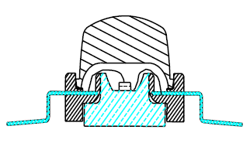

Fig. 1. The schematic diagram of LED package.
Author(s): David T.W. Lin, Chong-Ching Chang, Chung-Neng Huang
Title: The Minimum of Thermal Resistance Design of High Power LED Package

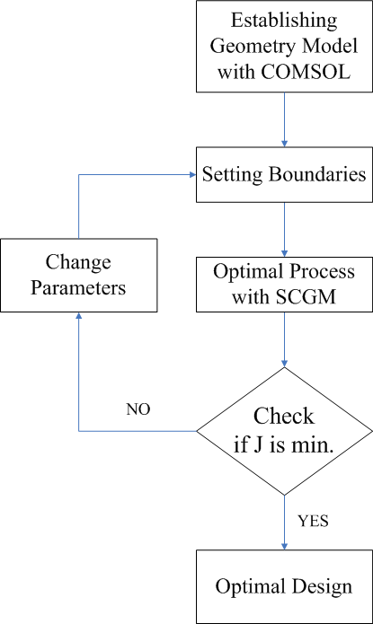
Fig. 2. The flow chart of the SCGM optimal process.
Author(s): David T.W. Lin, Chong-Ching Chang, Chung-Neng Huang
Title: The Minimum of Thermal Resistance Design of High Power LED Package
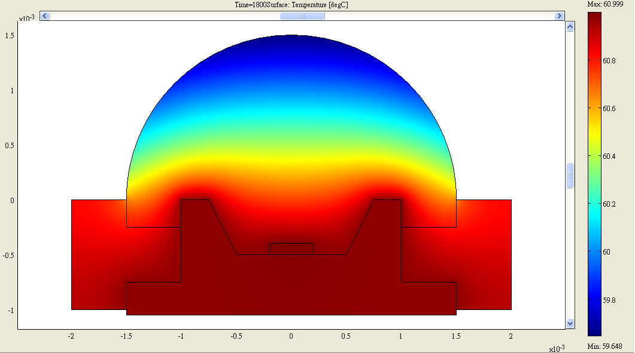
(a)
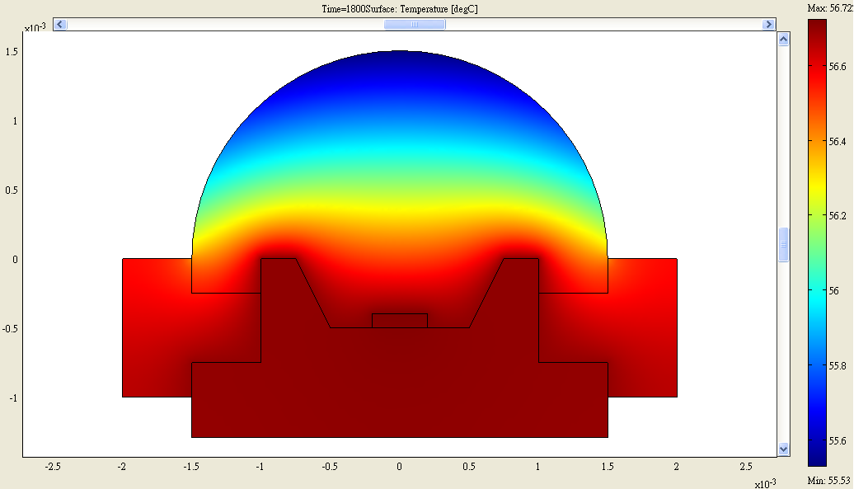
(b)
Fig. 3. The temperature profile of the LED package (a) before optimization, (b) after optimization.

Author(s): David T.W. Lin, Chong-Ching Chang, Chung-Neng Huang
Title: The Minimum of Thermal Resistance Design of High Power LED Package
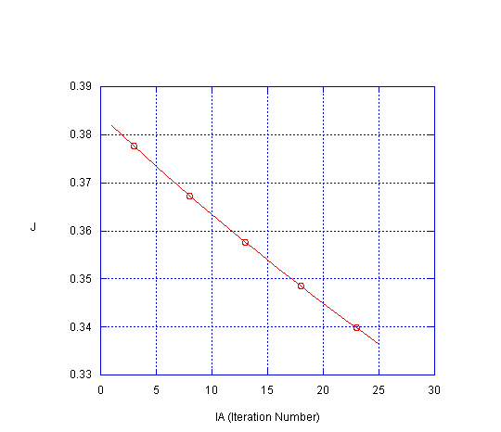
Fig. 4. The variation of objective function through the optimal process.

Author(s): David T.W. Lin, Chong-Ching Chang, Chung-Neng Huang
Title: The Minimum of Thermal Resistance Design of High Power LED Package
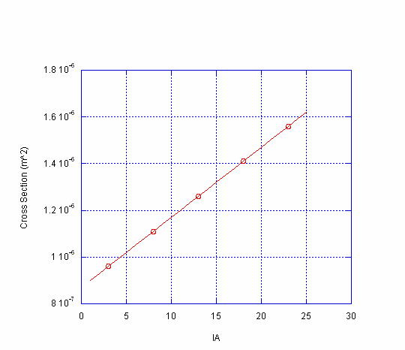
Fig. 5. The variation of cross section of the LED heat sink through the optimal process.

